The effect of linguistic input on event conceptualization.

May 2023

**Intro**

Much work has been done on the segmentation of time into discrete telic events. Within the context of these events, we have seen that particular precedent is given to the beginning and ending states of these events, but that much of the internal structure of an event remains to be understood. It has been proposed that the progression of an event is marked by the changes to the state of an object (Altmann & Ekres 2019), undergoing small transitions until it reaches an end state. However, the end state of an event is not inherently clear, and Mathis & Papafragou 2022 explore how the internal structure of an event, including its endpoint, is affected by linguistic input. The goal of an event is often considered in terms of its physical culmination, but events are equally propelled by internal, mental goals. For example, the event of making coffee can be considered either as the culmination of several intermediate steps such as grinding beans and boiling water, or it can be considered as the success of an agent’s internal goal, where the intermediate steps are not a crucial part of the eventual structure.

Mathis & Papafragou 2022 examined the relationship between the two senses of goal completion by ascribing different goals to the same action. For example the same picture of an orange being peeled would be shown with either goal of using the peel as a garnish or with the goal of eating the orange. Given that the second goal requires a further progression of peeling than the first, these contextualizing goals were expected to evoke a difference in event structure, where the first goal reached its endpoint sooner in the physical event than the second. This was borne out in the results, where participants judged partially completed physical events as functionally complete when given a lower goal 50% of the time, as compared to the 5% acceptance of completion across all items regardless of goals.

Thus, we see that the mental representation of event structure and endpoints can be influenced by internal state, and is not solely reliant on the progression of change to an object. However, the structure of Mathis & Papafragou 2022 places emphasis on goal completion, as opposed to goal progression. Although it is informative about the overall structure of events, it still obscures the internal structure, which we can better measure by examining event progression. Thus, in this study we plan to expand upon the work of Mathis & Papafragou 2022 and investigate the effect of goals on event memory.

It is well known in the psychological field that people are not reliable reporters of events, even those they have personally witnessed. This is due to the fact that memory is an amalgamation of actual visual input and the structure or meaning that the viewer has ascribed to it. One example of this is the phenomenon of representational momentum, where people unknowingly progress actions beyond the physical state they last witnessed. This has been observed in many domains, ranging from motion events to pitch, to social status. In these studies, participants are shown stimuli progressing along some axis that is suddenly cut off, and are asked to try to recover the last exemplar that they were exposed to. In most cases, [fact check this], the result was that the participant believed themself to have seen a further progression of the event than they did in reality, revealing the influence of their mental model of the event progression. Thus, in this study we hope to use the experimental paradigm of representational momentum to examine the effect of goals on event progression.

**Norming**

To validate the stimuli used, two norming studies were run to confirm a difference in event progression between the high and low goals. Each of these were run on the university’s subject pool with 30 participants in the first norming study and [] participants in the second. Participants were shown an image depicting the beginning state of the event, and asked to rate on a scale of 0 to 100 how much the event must progress in order to fulfill the goal. These ratings provided an aggregated assessment of what thresholds must be reached to achieve a goal. Across these two iterations of the norming study, high goals consistently received higher progression ratings than low goals for each item. The item-specific thresholds were less consistent, but low goals were rated 50.45 on average, while high goals were 82.43. From these, the goals used in the following experiments were validated in the second norming study, with two reversions to the initial set of goals and one alteration.

**Experiment 1**

Experiment 1 used the forced choice method seen in Hafri et al 2022’s experiment 4a. In this study, participants first saw the goal and the initial state, then observed a stop-motion animation of the event that was cut off at some midpoint. They were then presented with a forced choice task asking them to identify the last frame that they saw before the video ended. However, in keeping with the method in Hafri et al 2022, neither choice was correct. Instead, one choice was 10% completion prior to the true frame and the other was 10% completion after the true frame[1]. This experiment ran a 2 x 3 design over 18 target items and 11 filler items, varying the goal type (low, high) and the progression (25, 50, 75) within subjects. A no goal version was also run simultaneously to gauge a baseline effect of memory error without linguistic influence.

These were run on the university’s subject pool with a total of 54 participants (29 with goals, 24 without).

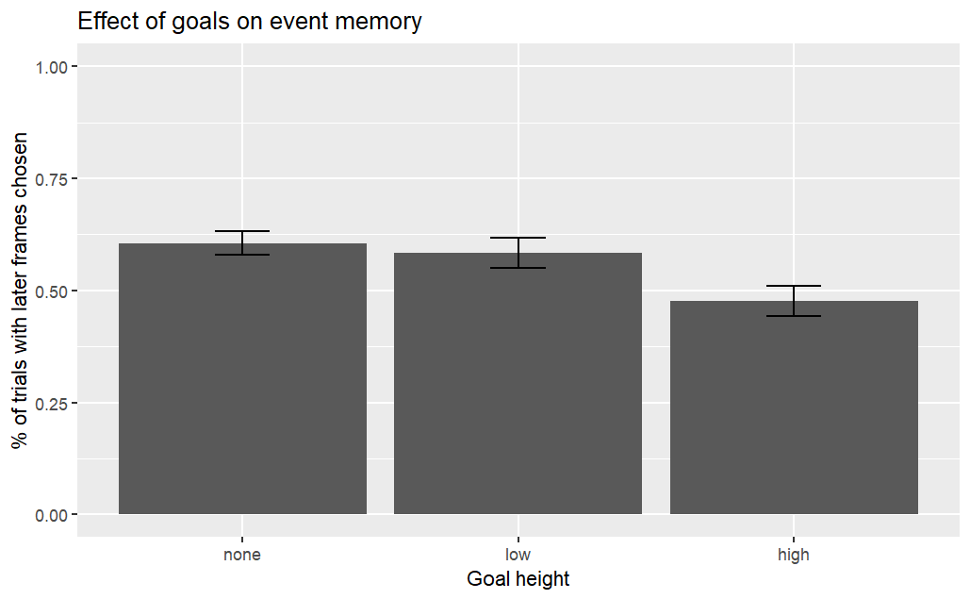

These results showed a slight but clear pattern of forward error in the none and low goal conditions, but no clear directional error in the high goal condition. To solidify the trend, we then ran it on Prolific, aiming for 30 responses in each condition. These results confirmed the trend.

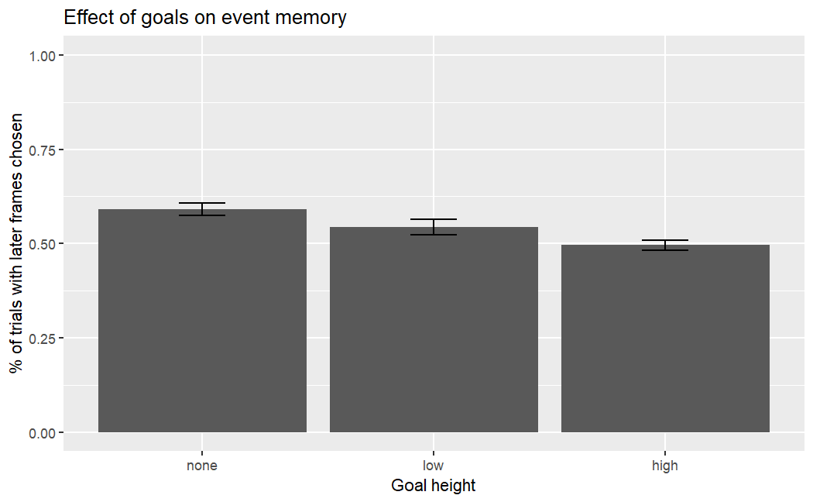

**Experiment 2**

The next experiment served the dual purpose of probing both the accuracy of participants’ memory and also the overall magnitude of the displacement error. In this experiment, participants were once again shown a stop-motion animation that was cut off at 25%, 50%, or 75% completion. However, instead of a forced choice between two incorrect options, participants were asked to choose the last frame that they saw in the truncated video. This was run on Prolific with at total of 114 participants (intended to be 30 in each of the none, low, and high conditions, but accidentally overenrolled in one condition). The results from this experiment are in contrast with those of Experiment 1, showing that in the no goal condition participants have a less directional pattern of error than in either of the conditions containing goals. The below graph shows not the proportion of binary choices in the forward or backward direction, but illustrates the magnitude of the memory error. In all conditions, there is a notable amount of variation in the participant choices, something to consider as we continue.

Option 1: The results here are accurate, and there is some way to reconcile these two experiments under one theory

Option 2: Error has been introduced through the stimuli by use of inconsistent event types, goal calibrations, or something similar

Option 3: Error has been introduced through the experimental design-- participants were not required to move the randomized slider before continuing, so this might reflect some of those unaltered responses. Retroactively eliminating this data would likely involve filtering reaction times based on the last item logged in PCIbex. Preventing this in the future would require editing the video_scrubber element in PCIbex to prevent a participant from continuing if they have not moved the slider (I would ask June how to do that)

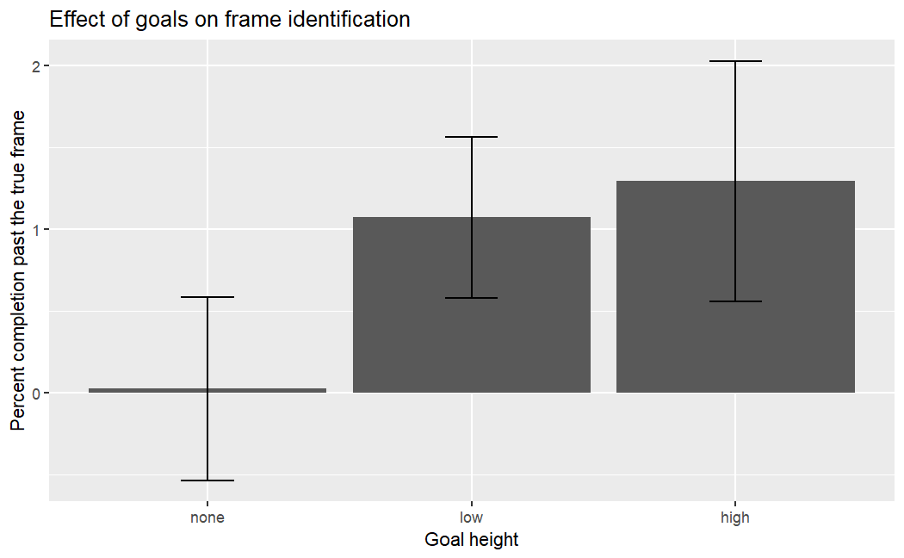

1. In most stimuli, this came out to be 2 frames before and after, but some stimuli (ex. cake) have 33 images, so 10% was best approximated by 3 images away.